**Software Requirements Specifications**

**Stock Registering**



**Submitted in the partial fulfilment of the requirements of the course**

**CS223-Software Engineering**

Submitted by

Sai Kishore Kesaram(B16CS028)

Sairipally Sai Surya(B16CS029)

**Table of Contents**

1. Introduction
   1. Purpose
   2. Scope
   3. Constraints
   4. Assumptions
   5. Definitions and Abbreviations
2. Overall Description
   1. Product Functions
      1. Functional Requirements
      2. Non Functional Requirements
   2. User Characteristics
3. Specific Requirements
   1. Use case description
   2. Design Constraints
4. **Introduction**
   1. **Purpose**

The purpose of this document is to provide a description of store and its management system. It explains the purpose and features of the system, what the system will do, system interfaces, constraints under which it operates and how system reacts to changes in environment (external or internal).

* 1. **Scope**

This software will be a management system for purchases and transactions of a store. This is designed to maximize productivity of a store by assisting it during its purchase and transactions otherwise would have been performed manually.

This system is designed to fully automate the transactions of the store. This software will provide quick connection between the customer and the store via an online platform. This system contains a list of consumable and non consumable goods available in the store and purchase histories.

* 1. **Constraints**

All users must login into the system using their login credentials.

This technology is free to be used by development team in order to provide a solution for any related assigned problem. The software used in development can handle limited number of users and the server capacity on which the software system is hosted is also limited. This system can be used for any general store by changing their consumable and non consumable goods but it requires internet connection.

* 1. **Assumptions**

We assumed a store refers to a general store. We have assumed that the username and password of various customers is already assigned. We assumed the number and prices of the good according to our convenience. Delivery of goods time is negligible. The balance of the store is assumed to be so high that any ordered goods not in stock can be bought.

* 1. **Definitions and Abbreviations**

|  |  |
| --- | --- |
| **Term** | **Definition** |
| Customer | Basic user who purchases the goods. |
| Login Credentials | Username and password the customer should have  In order to use our services. |
| Database | It takes the customer inputs and forwards it to the corresponding medium. |
| System | It is a medium that takes decisions. |
| Payment Portal | It is a medium where all the transactions are carried out. |
| Supplier | It is some third party who supplies unavailable goods to the store. |
| Store | It means an Online General Store where a customer can purchase goods of his required. |

1. Overall Description
   1. **Product Functions**
      1. **Functional Requirements**

Functional requirements are :

* Login Page for logging into the database using customers’ username and password.
* Purchase request page by which a customer can make a request for his purchase.
* Processing payment via payment portal.
* Keeping user informed about stock availability.
* Total balance verification.
* Accepting the order of goods only for which payment is made
  + - 1. **Use case Diagrams**
         1. **Use Case Login**

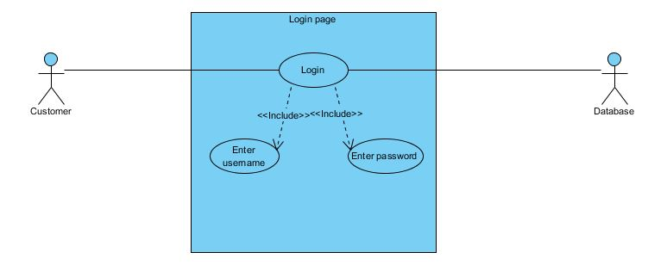

* + - * 1. **Use case Homepage**

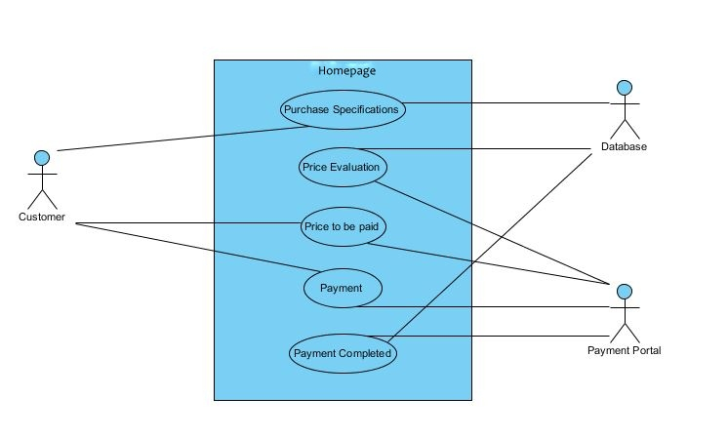

* + - * 1. **Use case diagram: Purchasing goods not in stock**

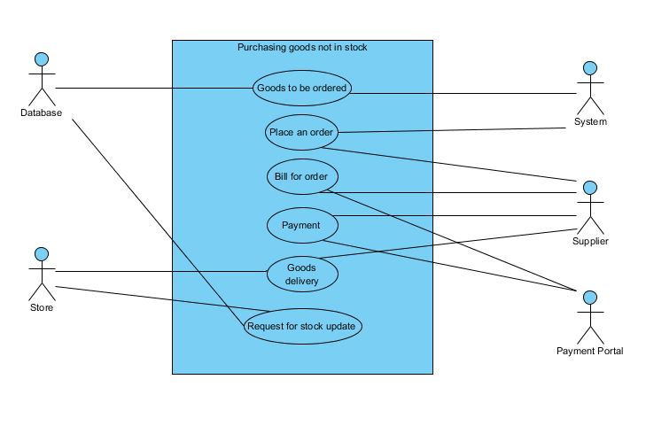

* + - * 1. **Use case Diagram: Delivering goods to customer**

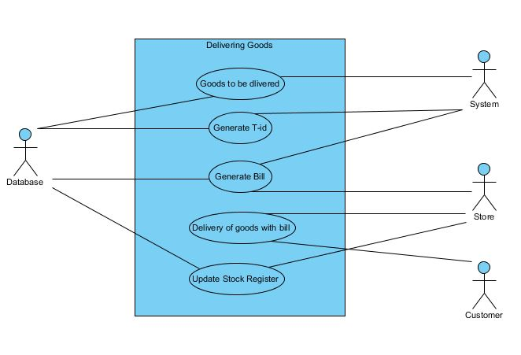

* + - * 1. **Use case Daigram: Logout**

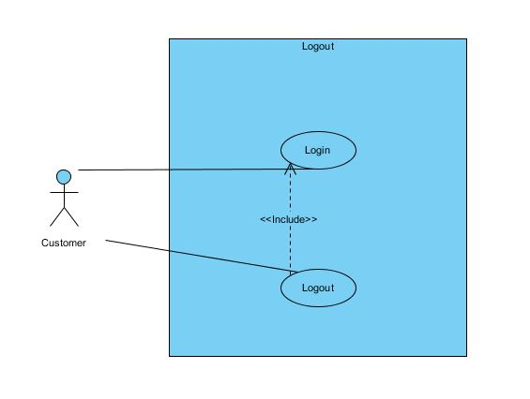

* + - 1. **Class Diagram**

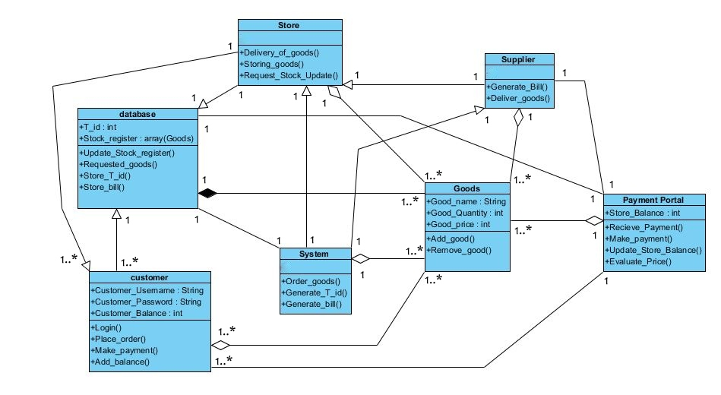

* + - 1. **Sequence diagram**
         1. **Sequence Diagram Login**

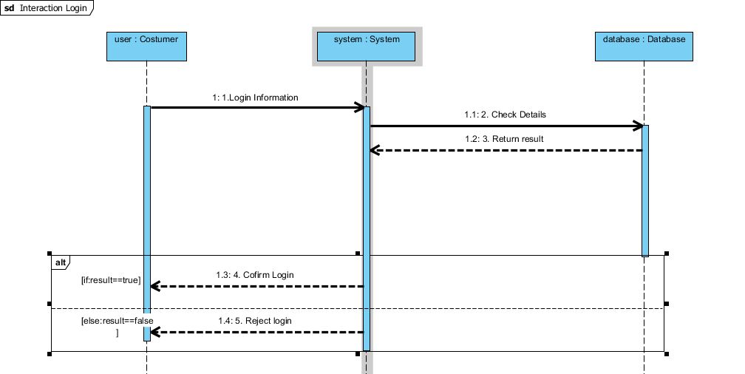

* + - * 1. **Sequence Diagram Working**

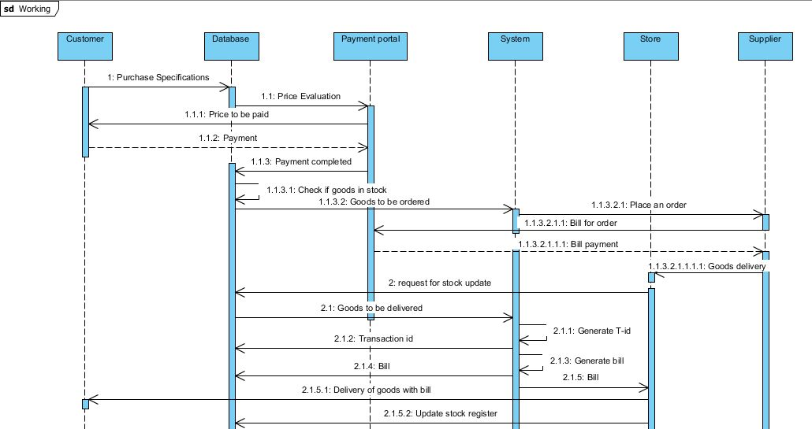

* + - * 1. **Sequence Diagram Logout**

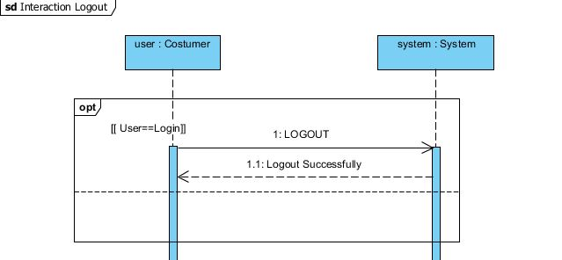

* + - 1. **Activity Diagram**
         1. **Activity login**

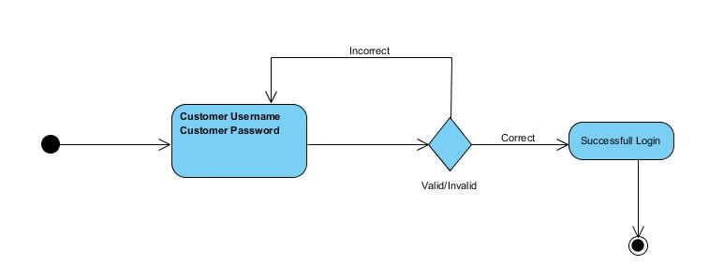

* + - * 1. **Activity purchase specifications**

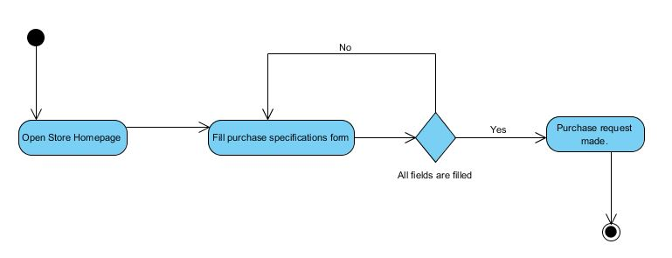

* + - * 1. **Activity making payment**

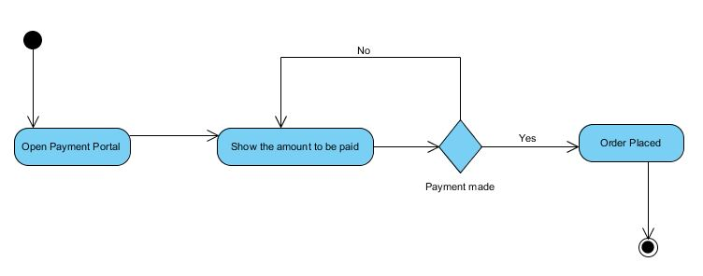

* + - * 1. **Activity delivering goods**

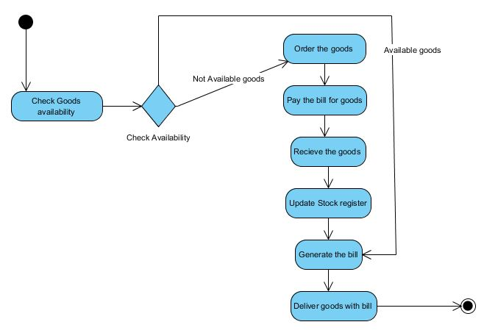

* + 1. **Non Functional Requirements**
* Our software is designed to manage the stock and sales of an online general store.
* Sufficient internet connection is required for proper execution of all functions
* All the data related the stock register system will stored in a database on a server.
* Modern web browsers are required to open web-based system.

* 1. **User Characteristics**

User Characteristics are as follows:-

* The customer should have a proper internet connection and should be able to Login and send his/her request for purchase.
* The user must be able to use various functionalities which are give to him in the system.

1. **Specific Requirements**
   1. **Use case description**
      1. **Customer Login**

|  |  |
| --- | --- |
| **Use case name** | Login |
| **Trigger** | Customer fills the username and password. |
| **Precondition** | The customer should have username and password. |
| **Basic Path** | The customer fills his username and password in login webpage. |
| **Alternative Paths** | No alternative path. |
| **Post Condition** | The customer is taken to the homepage. |
| **Exception Paths** | Every available field is to be filled |
| **Others** | None |

* + 1. **Homepage**

|  |  |
| --- | --- |
| **Use case name** | Homepage |
| **Trigger** | Customer selects the required goods. |
| **Precondition** | Customer has to be logged-in. |
| **Basic Path** | 1. The price of the selected goods are been evaluated and the output is viewed by the customer.  2. Customer has to complete the payment to the payment portal. |
| **Alternative Paths** | No |
| **Post Condition** | Order for goods not in stock |
| **Exception Paths** | No |
| **Others** | None |

* + 1. **Purchasing ordered goods not in stock**

|  |  |
| --- | --- |
| **Use case name** | Purchasing goods not in stock |
| **Trigger** | Database decides the goods to be ordered. |
| **Precondition** | Completion of payment for goods. |
| **Basic Path** | 1. Ordered goods not in stock are placed as an order to the supplier.  2. Supplier provides a bill for the goods ordered which is cleared by payment portal.  3. After the clearance of the bill supplier delivers the ordered goods to the store. The stock registered is updated. |
| **Alternative Paths** | No |
| **Post Condition** | Delivering goods to the customer. |
| **Exception Paths** | No |
| **Others** | None |

* + 1. **Delivering goods to the customer**

|  |  |
| --- | --- |
| **Use case name** | Delivering goods to the customer |
| **Trigger** | Database provides the list of goods to be delivered, to the system |
| **Precondition** | This happens only after all the ordered goods are in stock. |
| **Basic Path** | 1. The goods to be delivered to the customer are evaluated and a bill is generated.  2. The goods are delivered to the customer with the bill and stock register is updated. |
| **Alternative Paths** | None |
| **Post Condition** | None |
| **Exception Paths** | None |
| **Others** | No |

* 1. **Design Constraints**
     1. **Software language**

All codes will be written in C++.